**EXERCISE NO:11**

**NAME:M.SUBASH KUMAR(20UCS089)**

**PROGRAM:**

**Main.Activity.java:**

package com.example.exe11;  
  
import androidx.appcompat.app.ActionBar;  
import androidx.appcompat.app.AppCompatActivity;  
  
import android.app.Activity;  
import android.app.AlertDialog;  
import android.content.DialogInterface;  
import android.content.SharedPreferences;  
import android.content.res.Configuration;  
import android.os.Bundle;  
import android.view.View;  
import android.widget.Button;  
  
import java.util.Locale;  
  
public class MainActivity extends AppCompatActivity {  
 Button b1;  
  
 @Override  
 protected void onCreate(Bundle savedInstanceState) {  
 super.onCreate(savedInstanceState);  
 loadLocale();  
 ActionBar ac = getSupportActionBar();  
 ac.setTitle(getResources().getString(R.string.*app_name*));  
 setContentView(R.layout.*activity_main*);  
 b1 = (Button) findViewById(R.id.*button*);  
 b1.setOnClickListener(new View.OnClickListener() {  
 @Override  
 public void onClick(View view) {  
 showChangeLanguage();  
  
 }  
 });  
  
 }  
  
 private void showChangeLanguage() {  
 final String[] listItems = {"Tamil","Telugu"};  
 AlertDialog.Builder m = new  
 AlertDialog.Builder(MainActivity.this);  
 m.setTitle("Choose Language");  
 m.setSingleChoiceItems(listItems, -1,  
 new DialogInterface.OnClickListener() {  
 @Override  
 public void onClick(DialogInterface dialogInterface, int i) {  
 if (i == 0) {  
 setLocale("ta");  
 recreate();  
 } else if (i == 1) {  
 setLocale("te");  
 recreate();  
 }  
 dialogInterface.dismiss();  
  
 }  
 });  
 AlertDialog mDialog = m.create();  
 mDialog.show();  
 }  
  
 private void setLocale(String lang) {  
 Locale locale = new Locale(lang);  
 Locale.*setDefault*(locale);  
 Configuration c = new Configuration();  
 c.locale = locale;  
 getBaseContext().getResources().updateConfiguration(c, getBaseContext().getResources().getDisplayMetrics());  
 SharedPreferences.Editor e = getSharedPreferences("settings", *MODE_PRIVATE*).edit();  
 e.putString("Mylang", lang);  
 e.apply();  
  
 }  
  
 public void loadLocale() {  
 SharedPreferences pre = getSharedPreferences("settings", Activity.*MODE_PRIVATE*);  
 String lang = pre.getString("Mylang", "");  
 setLocale(lang);  
  
 }  
}

**activity_main.xml:**

*<?*xml version="1.0" encoding="utf-8"*?>*<androidx.constraintlayout.widget.ConstraintLayout xmlns:android="http://schemas.android.com/apk/res/android"  
 xmlns:app="http://schemas.android.com/apk/res-auto"  
 xmlns:tools="http://schemas.android.com/tools"  
 android:layout_width="match_parent"  
 android:layout_height="match_parent"  
 tools:context=".MainActivity">  
  
 <LinearLayout  
 android:layout_width="409dp"  
 android:layout_height="729dp"  
 android:orientation="vertical"  
 tools:layout_editor_absoluteX="1dp"  
 tools:layout_editor_absoluteY="1dp">  
  
 <EditText  
 android:id="@+id/editTextTextPersonName"  
 android:layout_width="match_parent"  
 android:layout_height="wrap_content"  
 android:ems="10"  
 android:inputType="textPersonName"  
 android:text="@string/uname" />  
  
 <EditText  
 android:id="@+id/editTextTextPersonName2"  
 android:layout_width="match_parent"  
 android:layout_height="wrap_content"  
 android:ems="10"  
 android:inputType="textPersonName"  
 android:text="@string/pwd" />  
  
 <Button  
 android:id="@+id/button"  
 android:layout_width="match_parent"  
 android:layout_height="wrap_content"  
 android:text="@string/cl" />  
  
 <Button  
 android:id="@+id/button2"  
 android:layout_width="match_parent"  
 android:layout_height="wrap_content"  
 android:text="@string/login" />  
 </LinearLayout>  
</androidx.constraintlayout.widget.ConstraintLayout>

**String.xml:**

<resources>  
 <string name="app_name">exe 11</string>  
 <string name="uname">User name</string>  
 <string name="pwd">Password</string>  
 <string name="cl">Change Language</string>  
 <string name="login">Login</string>  
</resources>

**ta/string.xml:**

*<?*xml version="1.0" encoding="utf-8"*?>*<resources>  
 <string name="app_name">exe 11</string>  
 <string name="uname">பயனர் பெயர்</string>  
 <string name="pwd">கடவுச்சொல்</string>  
 <string name="cl">மொழி மாற்றம்</string>  
 <string name="login">உள்நுழைய</string>  
</resources>

**te/string.xml:**

*<?*xml version="1.0" encoding="utf-8"*?>*<resources>  
 <string name="app_name">exe 11</string>  
 <string name="uname">వినియోగదారు</string>  
 <string name="pwd">పాస్వర్డ్</string>  
 <string name="cl">భాష మార్చు</string>  
 <string name="login">ప్రవేశించండి</string>  
</resources>

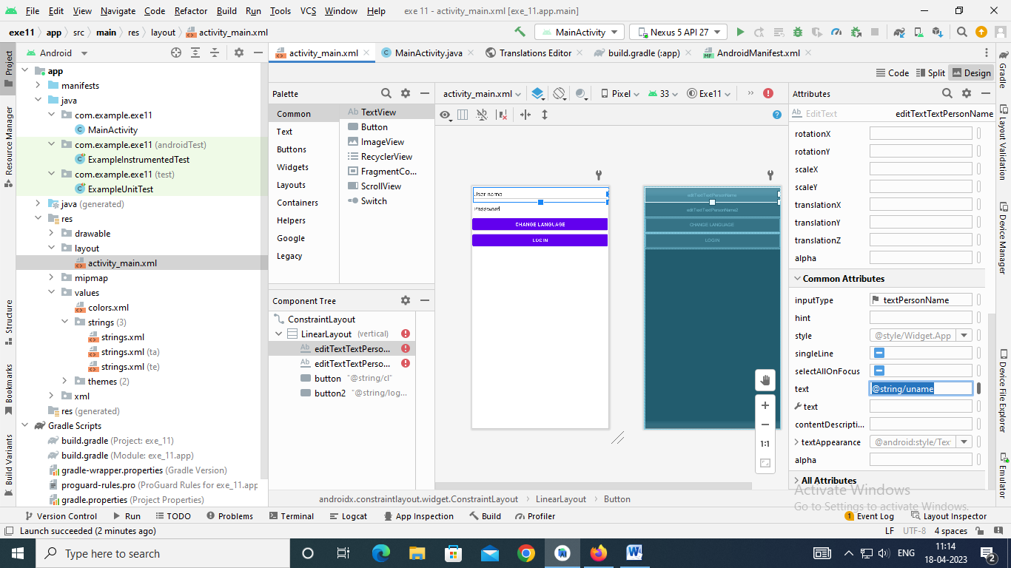

**OUTPUT:**

